Computer Language Coding Concepts

Inactive Clauses in a Command Definition in a Diagram
This article demonstrates a situation of command objects.

This article illustrates how inactive clauses in a command definition look in a diagram.

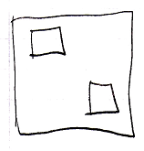

The larger square is a command definition. The smaller squares inside the larger square are inactive clauses inside a command definition. Squares inside a square, that do not redirect, are inactive clauses.

See also: Commands

Author & Copyright: Jan-Joost van Zon Date: August 9, 2008 – August 23, 2008 Location: Oosterhout, The Netherlands Status: Finished

